**Project report 14.11.2019 – 4.12.2019**

Emre Özincegedik

**Code Implementation, Interface Implementation and Combining all (Continued) 14.11 – 30.11**

Due to nature of coding, interface and coding will be done concurrrently

**lamp control (114 locs):**

lamp control is done via bluetooth connection. So command will come via Serial Connection. Since Serial communication uses ascii characters, sending a character via Serial communication will be received as character’s ascii decimal correspondence.

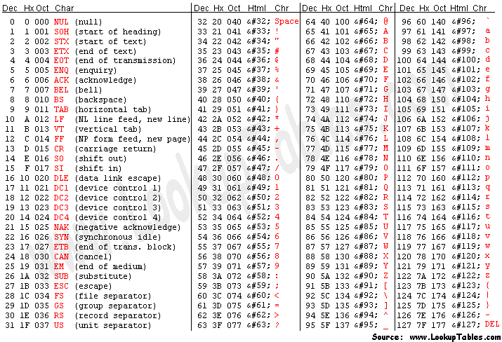

**Electric shortage (45 locs):**

Electricity has 2 main statuses: On status and off status. Each status has 2 small parts. Changing from 1 status to another and staying on same status. Changing from On to off gives us the electricity shortage moment. While at Off state we start counting time from shortage moment. Changing from Off to On allows us to stop timer. Staying On does nothing.

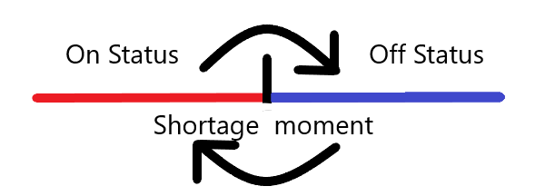

**Display (36 locs)**

While implementing interface, some unforeseen circumtances made me change interface. The OLED screen is so small for the planned interface so lamp statuses are in the same row now, also current date is removed but current time is still shown:

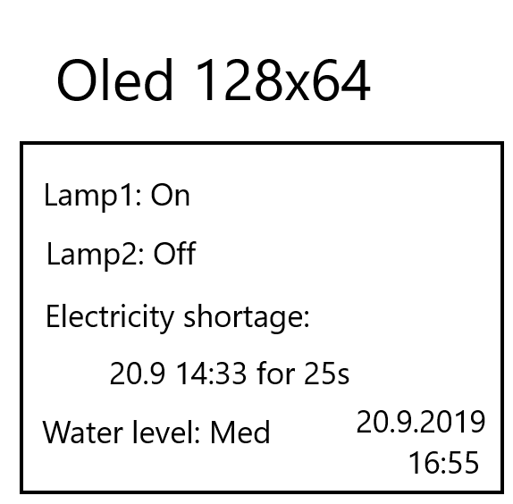

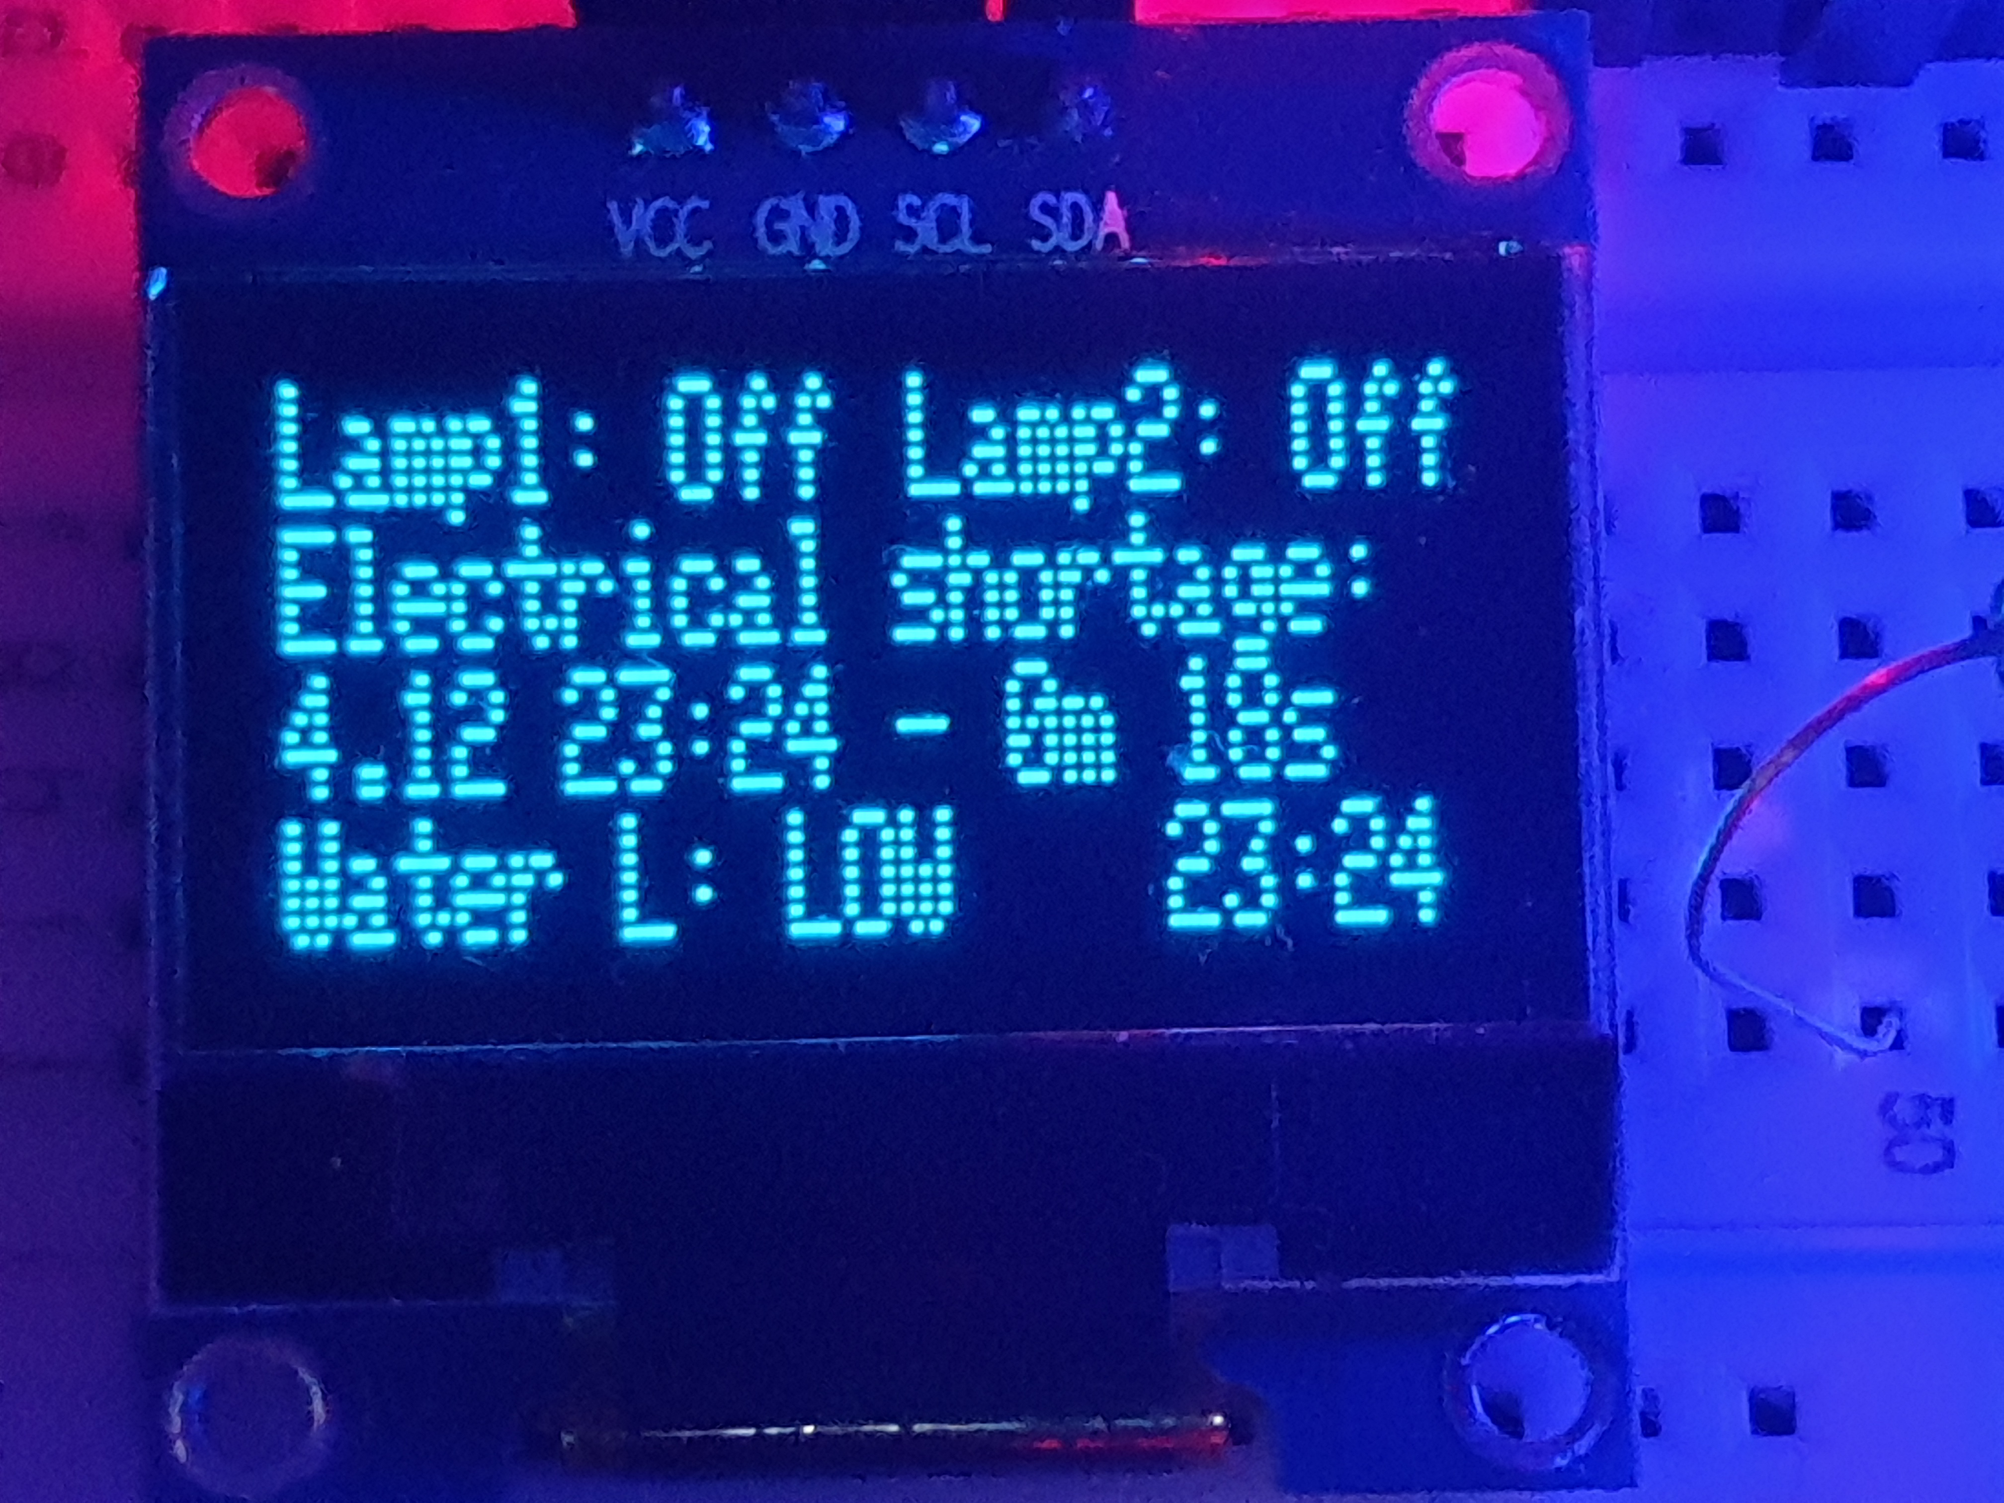

**phone (35 locs? Done in MIT App inventor)**

Same with the OLED Screen, there was alteration to interface. Because of the nature of Bluetooth connection, there has to be a button to connect Bluetooth module.

Side note: Debugging with MIT App Inventor is really hard, not recommended for future projects

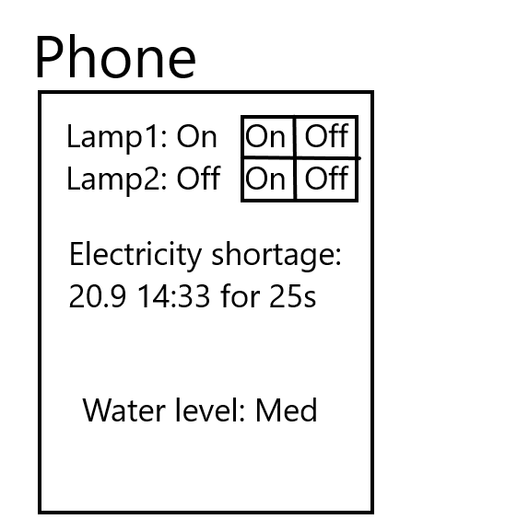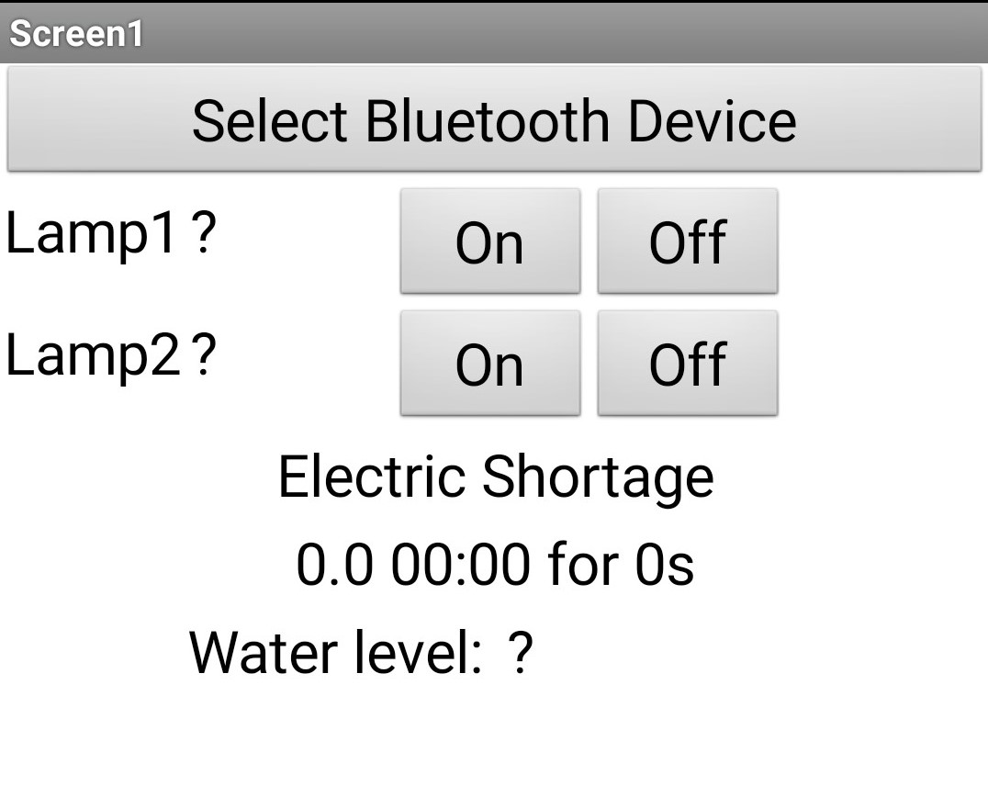

**Full code:**

**265 locs for project’s Arduino part**

**35 locs for project’s phone part**

**Determining Tests 1.12 – 4.12**

Wiring test: What happens if wires are disconnected?

Project heavily depends on modules being connected. If there are problems with wire connection or inside of the wires, project wouldn’t work as expected even though modules do their job accordingly.

Expected Impact: HIGH

Expected Occurrence: LOW

Needs normal monitoring

Interface test: What happens if different phone is used?

OLED Screen is fixed size but only my phone is used right now. Changing phone would mean different screen size, therefore positions of items would change.

Expected Impact: LOW

Expected Occurrence: HIGH

Needs normal monitoring

Code test: What happens if too much information is presented at the same time?

Arduino is powered via battery, so code needs to be optimized as much as possible. Too much information and processing would lower battery life

Expected Impact: HIGH

Expected Occurrence: LOW

Needs normal monitoring